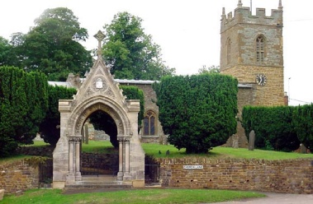
COLD ASHBY
ANNUAL PARISH ASSEMBLY
minutes
Wednesday 16th June 2021

The annual Cold Ashby Parish Assembly took place on Wednesday 16th June at 8 p.m. (approx.) in the Sport Pavilion.
Minutes
1. Election of chairman for the meeting: the chairman of the PC took the chair.
2. Present: 18 people were present, including a member of the Lib Dem election team.
3. Minutes of the 2018 assembly had been available on the website and were taken as read.
4. Welcome and introduction – the chairman explained the purpose and nature of the meeting and provided an account of the activities of the PC since the last assembly. (a separate report is available on request to the PC clerk.)
5. Future of the Village Hall: the chairman explained the difficulties facing the village hall and that a small committee had undertaken to engage the village in debate about its future. There were questions (but no firm answers) about the status of the hall (as a ‘war memorial’ and as a ‘village hall’) but neither of these are mentioned in the Trust Deed which defines the character and purpose of the building and its management. The Charities Commission has ultimate control but would look to transfer the trust responsibilities to another charity with similar charitable objectives.
6. Information session (and general discussion) on: village pub; golf centre; Capfa projects and plans; VAS and traffic, litter, use of Streetlight savings
- Pub: Little information available on the intentions of the new owner.
- Golf Centre: pleased to see revival well under way
- Capfa undertaking major power and facilities work.
- New VAS unit paid for by grant from police
- Litter under the auspices of newly reformed CAPEG – now environment focused.
- Streetlight savings realised and being used to build a reserve for new cemetery land.
The following issues were also raised: pollution from traffic in the village is now increasingly in evidence and should be a greater focus in campaigning material. House windows need very frequent cleaning. The chairman explained that efforts to secure a 20-mph zone were underway. Residents wondered in WNC would be more sympathetic to the idea of ‘sleeping policemen’. One resident asked if consideration had been given to bollards along main street to prevent traffic driving along pavements (an issue with a long history – bollards are usually destroyed, within days of being erected, by farm or other large vehicles). The chairman explained the purpose of the ANPR camera on the Naseby Road approach to the village.
8. Reports from WNC Councillors if present – none present but all had indicated interest in future PC and other meetings and pledged support (Cecile Irving-Swift, Kevin Parker and Jonathan Harris)
9. Open Forum – all issues dealt with in the above items. Chairman thanked everyone for a lively and positive meeting.
G Jones
CAPC clerk June 2021

